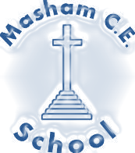

Curriculum

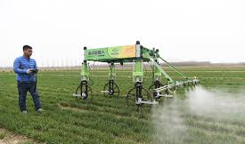
Computing

Clark’s Farm, Masham

INTENT
In line with the 2014 National Curriculum for Computing, our aim is to provide a high-quality computing education which equips children to use computational thinking and creativity to understand and change the world. The curriculum will teach children key knowledge about how computers and computer systems work, and how they are designed and programmed. Learners will have the opportunity to gain an understanding of computational systems of all kinds, whether or not they include computers and those which are relevant to the children’s lifestyles.
By the time they leave Masham, children will have gained key knowledge and skills in the three main areas of the computing curriculum: computer science (programming and understanding how digital systems work), information technology (using computer systems to store, retrieve and send information) and digital literacy (evaluating digital content and using technology safely and respectfully). The objectives within each strand support the development of learning across the key stages, ensuring a solid grounding for future learning and beyond.
IMPLEMENTATION
We follow the Purple Mash progression of skills, a summary of which can be seen below. In addition to this we provide input and stimulation relevant to our children, such as the use of specific farming machinery or opportunities to excel digitally.
Examples of the additions to the curriculum are:
- Where possible, the use of technology will be used to support cross-curricular learning
- Digital Leadership programme
- The use of Self-organised learning environments (SOLE)
- Familiar with using Microsoft Office by the end of Key Stage 2 in preparation for Secondary School and the wider world.
- Access to ipads using a variety of apps such as Green Screen and Movie Maker to develop creativity.
- Use of physical objects such as robots for programming.
- Provide off-line opportunities to develop computational thinking and problem solving.
IMPACT
The impact of our computing curriculum can be seen on Purple Mash; a digital platform where children can complete and evaluate their own work. Evidence such as this is used to feed into teachers’ future planning, and as a topic-based approach continues to be developed, teachers are able to revisit misconceptions and knowledge gaps in computing when teaching other curriculum areas. This supports varied paces of learning and ensures all pupils make good progress.
Much of the subject-specific knowledge developed in our computing lessons equip pupils with experiences which will benefit them in secondary school, further education and future workplaces.
(To be read alongside the Computing Programme of Study: Key stages 1 and 2 National curriculum in England September 2013)
