Newsletter 10
17th November 2023
Dear Parents and Carers,
Miss Lawton is running the London Marathon next year and is fundraising for the YMCA. Your child will bring home a flyer tonight with some exciting activities she will be running, outside of school hours, in the next few weeks!

In the Spotlight!
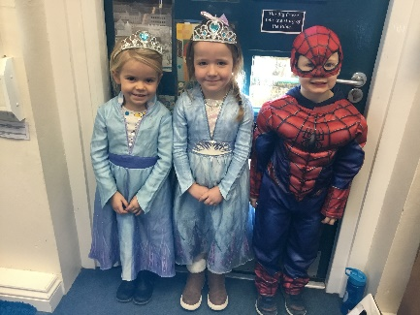
What an impressive array of costumes we’ve seen today as the children dressed as their favourite person in the spotlight to raise money for Children in Need. Strictly Come Dancing seemed to be a popular choice but there were also a selection of magical (and slightly spooky) wizards and Wednesdays, sportspeople, presenters and even the odd retro pop star thrown in for good measure! Lots more pictured are on the Facebook page. Well done everyone, a super effort and we look forward to letting you know the total we raised next week!

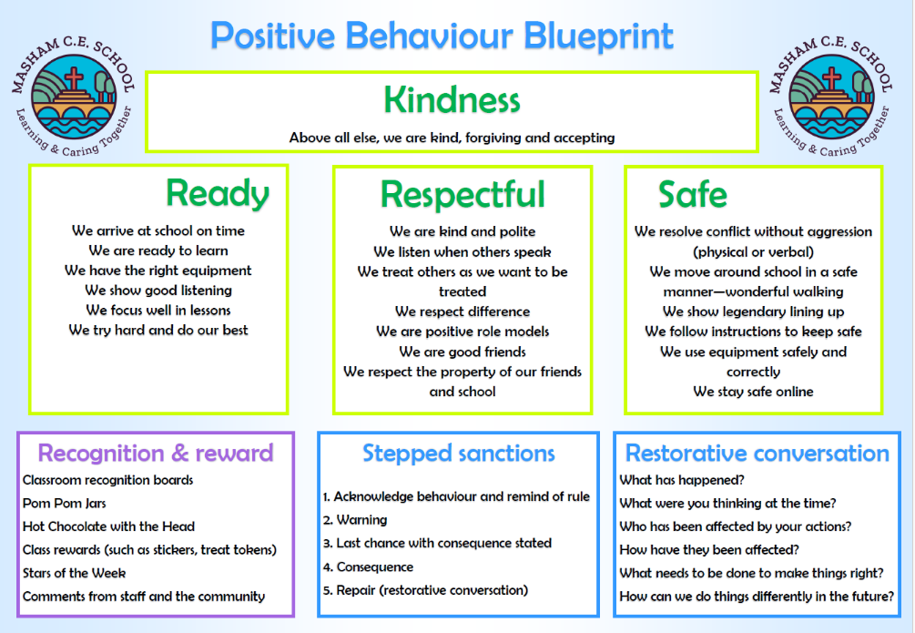
Behaviour Blueprint.
We were so pleased last week to have some fantastic feedback about the children’s behaviour while they were out and about; Laver Class represented our school beautifully at the Remembrance Service on Friday, Burn and Cover Class were excellent on their visit to Jorvik and Dig in York and Swinney Class were fantastic in the forest! A reminder of our behaviour blueprint is attached – we like to share this regularly with parents and carers so we are all working together.

Parent Carer Survey
It has been lovely to see so many of you at Parent Teacher consultations this week – attached to this newsletter is a link to our annual parent/carer survey, we’d be grateful if you could find a few minutes to complete this by next Friday 24th November. Paper copies are available from the school office too if you would prefer. Thank you for your onging support.

Have a lovely weekend, don’t forget to follow us on Facebook!

Mrs F R Lawson-Ross, Head teacher

Dates for your diary

+Blue text indicates occasions where parents and carers are warmly welcomed to attend.
Friday | 24.11.23 | Cover | Celebration Assembly
Thursday | 30.11.23 | All | Pantomime
Friday | 01.12.23 | Burn | Celebration Assembly
Thursday | 07.12.23 | All | Christmas Crafts and Dinner Day
Thursday | 14.12.23 | KS1 | Nativity 6pm in the Town Hall
Friday | 22.12.23 | All | Christmas Service 1.15pm @ St Mary’s Church
Friday | 22.12.23 | All | School close for Christmas @ 2pm
Monday | 08.01.24 | Staff | Training Day
Tuesday | 09.01.24 | All | Children return to school
Tuesday | 15.01.24 | All | FOMS Meeting in school @ 7.30pm
Thursday | 01.02.24 | All | Skip 2B Fit Day
Wednesday | TBC | All | Musical Extravaganza
Friday | 09.02.24 | All | School Closes for half term @ 3.30pm
Monday | 19.02.24 | All | Children return to school
Thursday | 22.02.24 | All | World Thinking Day – Children in Rainbows, Brownies, Guides, Squirrels, Beavers and Scouts are welcome to wear to their uniforms to school.
Monday | 26.02.24 | All | Parents Evening
Monday | 26.02.24 | Year 6 | Bewerley Park
Thursday | 29.02.24 | All | Parents Evening
Thursday | 07.03.24 | All | World Book Day
Friday | 22.03.24 | All | Easter Service 1.15pm @ St Mary’s Church
Friday | 22.03.24 | All | School closes for Easter @ 2pm
Monday | 08.04.24 | Staff | Training Day
Tuesday | 09.04.24 | All | Children return to school
Monday | 06.05.24 | All | School closed for May Day
Wednesday | 08.05.24 | All | Skip 2B Fit Day
Tuesday | 21.05.24 | All | Sports Day Afternoon (Weather Dependent)
Thursday | 23.05.24 | All | Alternative Sports Morning
Friday | 24.05.24 | All | School closes for Half Term @ 3.30pm
Monday | 03.06.24 | Staff | Training Day
Tuesday | 04.06.24 | All | Children return to school
Wednesday | 10.07.24 | KS2 | Summer Performance
Thursday | 11.07.24 | Ks2 | Summer Performance
Thursday | 18.07.24 | Year 6 | Leavers celebration
Friday | 19.07.24 | All | Leavers Service 1.15pm @ St Mary’s Church
Friday | 19.07.24 | All | School closes for summer @ 2pm

Other trips, visits and exciting activities will be added as the year goes on.
Attendance
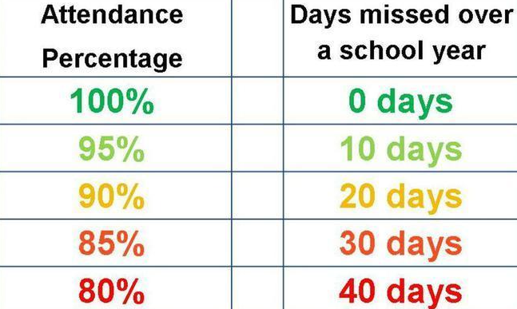
Swinney – 94.29%

Laver - 100%

Burn – 84.12%

Cover – 99%

Congratulations to Years 2, 3 and 6 who all got 100% attendance – fabulous effort, well done!

Swinney - Isaac J – for being a really kind friend this week
Luna – for heling others in our class
Conor – for trying hard to listen to instructions in
Forest School
Iliza – for trying hard with phonics
Laver - Maddie – for excellent worn on her Diwali booklet
Burn - Corey – for excellent focus in lessons this week
Cover - Leo – for his Norse myth work

