Dear Parents/Carers,

Welcome to Laver Class’s Autumn 1 newsletter. You will receive a class newsletter every half term to keep you informed of all the things happening in our class. All the children have made an excellent start to the new school year and settled well into our new class.

Curriculum
In English this half term, the children will be developing their handwriting, spelling and knowledge of grammar and punctuation. We will be using the book ‘A River’ by Marc Martin to help us to develop our sentence writing culminating in a circular story. Our first reading for pleasure book is ‘The Boy Who Grew Dragons’ by Andy Shepherd.

In maths, we are currently focussing on place value for two digit numbers (Year 2) and three digit numbers (Year 3) (e.g. understanding the value of each digit, how to break these numbers down and to compare and order them). We will then move onto applying this understanding to work on the four operations, addition, subtraction, multiplication and division. Children will also be learning about shape. You can learn more about these areas of maths on BBC Bitesize.

This half term, our geography topic is ‘The United Kingdom’.​ The children will learn about location and place, studying the human and physical features of the United Kingdom. They are already getting to grips with navigating atlases.

In our science work, Laver class are going to focus on plants whilst carrying out experiments and using a scientific process. Each child will take home a knowledge organiser next week for both science and geography that details the key knowledge they will gain from these subjects. In RE this half term, our learning is based around the enquiry questions: ‘How should we care for the world and others and why does it matter?’ (Year 2) and ‘What are the deeper meanings of festivals?’ (Year 3). We will explore and compare the beliefs and practices of different religions and the children will also have many opportunities to share their own beliefs and reflections. Our computing work will be based around understanding Information Technology around us. Year 3 children will develop their modern foreign language skills in a French unit called ‘This is Me’. There will also be lots of opportunities for creativity, including designing and making a mechanical fairground wheel in DT and playing instruments and singing in music.
PE
PE will normally be on a Tuesday and Wednesday. However, PE kits should be in school all week to allow for any changes in timetable. Children are not permitted to wear earrings for PE.

Homework
We are true believers that time at home is for different types of activities and we love to hear what the children have achieved whilst they are not at school. We know there are many talents in Laver Class and that the children attend many classes, groups and clubs out of school time - which is fantastic. However, parental support is invaluable in a child’s learning and regular homework will be introduced for Year 3 children.

Year 3 will be set weekly homework to build on, and consolidate, class learning. Children are expected to be able to complete this task independently and for it to take no longer than 15 to 20 minutes.

Reading
Reading and enjoying stories at home is imperative to developing a child’s reading skills and we expect children to read a minimum of three times per week at home. Please record in the home reading record each time your child reads at home. Children who are on the Little Wandle decodable books must read their books three times before changing to help them develop prosody and comprehension. They are welcome to take home another book along side their decodable book for bed time reading.

Reading
Here at Masham C.E. Primary School, our aim is to promote a love of reading in all our children.
Parents often ask us for recommendations of suitable books to read at home. As well as books recommended in our Knowledge Organisers, below is a list of high-quality texts (including thought provoking, classics and comedy) that we think you and your child would enjoy reading together this term. Masham Library is a great option for borrowing books and if they don’t have them in stock they can normally easily order them in from other libraries. We would love to hear how you get on if you are able to read them. We would also love to hear about any other books your children are reading or having read to them at home.

 | 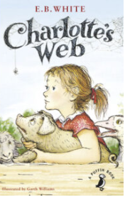 | 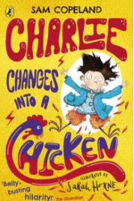 | 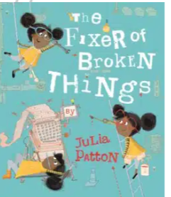 | 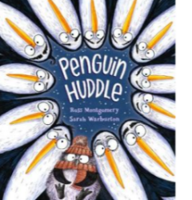
The Wild Robot by Peter Brown  (Year 3) | Charlotte’s Web by E B White  (Year 3) | Charlie Changes into a Chicken by Sarah Horne and Sam Copeland  (Year 3) | The Fixer of Broken Things by Julia Patton  (Year 2) | Penguin Huddle by Ross Montgomery and Sarah Warburton.

Key Dates

Key dates have been listed in the school’s weekly newsletter but may I draw your attention to the following:

Monday 18th September | The Railway Children (theatre show in school)
Friday 6th October | Harvest Festival 9am at St Mary’s
Friday 20th October | Showcase Afternoon (parents welcomed into school at 2:30pm)
Thursday 26th October | Firework Disco
Friday 27th October | Colour Run
Friday 27th October | SCHOOL CLOSES for Half Term

Many thanks for your cooperation and support. I look forward to working with all of you to ensure that your children have an excellent and enjoyable year in my class.

Should you require any further information, please do not hesitate to get in touch.

Mrs Clark
Laver Class Teacher

