Dear Parents/Carers,

Welcome to Cover Class’s Autumn 1 newsletter. You will receive a class newsletter every half term to keep you informed of all the things happening in our class. All the children have made an excellent start to the new school year and settled well into their roles as the oldest in the school.

Curriculum
In English this half term, the children will continue to develop their handwriting, spelling and knowledge of grammar and punctuation. We will be using the book ‘A Story like the Wind’ by Gill Lewis to help us to develop evocative sentence writing culminating in a flashback story. Our first reading for pleasure book is ‘Fablehouse’ by E.L. Norry.

In maths, we are currently focussing on place value for numbers of up to 7 digits (e.g. understanding how to break these numbers down and to compare them). We will then move onto applying this understanding to work on the four operations, addition, subtraction, multiplication and division.

This half term, our history topic is ‘How did England change during the settlement of the Anglo-Saxons and Vikings?’.​ The children will learn about British history between 400 AD and 1066 AD, with a focus on the invasions and settlements during this period. We are planning a trip to Jorvik in York to support the children’s learning within this topic and we will send another letter with further information about this trip soon.

In our science work, Cover class are going to focus on the properties of different materials whilst carrying out experiments and using a scientific process. In RE this half term, our learning is based around the enquiry question: ‘how do religions help people live through good times and bad times?’. We will explore and compare the beliefs and practices of different religions and the children will also have many opportunities to share their own beliefs and reflections. Our computing work will be based around safe and accurate searching alongside key online safety messages. The children will also continue to develop their French with an initial focus on transport. There will also be lots of opportunities for creativity, including making pop up books in DT and playing instruments and singing and music.

PE
As previously mentioned in Mrs Lawson-Ross’s newsletter, PE this half term will usually be on a Wednesday and the children will go swimming every Thursday afternoon for the next 10 weeks. PE kits should be in school all week to allow for any changes in timetable. Children are not permitted to wear earrings for PE.

Homework
We are true believers that time at home is for different types of activities and we love to hear what the children have achieved whilst they are not at school. We know there are many talents in Cover Class and that the children attend many classes, groups and clubs out of school time - which is fantastic. However, parental support is invaluable in a child’s learning and regular homework this year will also help the children to prepare for the transition to secondary school where homework will often be daily.

Cover class will be set weekly homework to build on, and consolidate, class learning. Children are expected to be able to complete this task independently and for it to take approximately 30 minutes. This homework will change each week depending on the needs of the class and sometimes children within the class may have different homework to each other. The homework will usually be maths or English based but may occasionally be based around their classwork in science, geography or history.

We will also share the class ‘knowledge organisers’ for our science and history/geography topics, so you are aware of the key facts that the children will be learning in their curriculum lessons each half term.

Reading
Here at Masham C.E. Primary School, our aim is to promote a love of reading in all our children. Reading and enjoying stories at home is imperative to developing a child’s reading skills. Even though many of the children are now reading fluently, regular reading aloud has been shown to help children to continue to develop their comprehension and confidence with texts.
Parents often ask us for recommendations of suitable books to read at home. Below is a list of high-quality texts that we think you and your child would enjoy reading together this term.

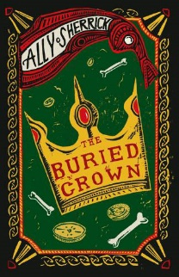 | 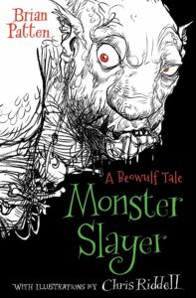 | 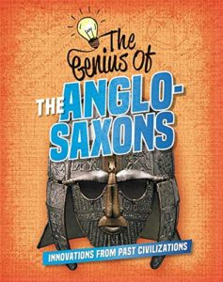 | 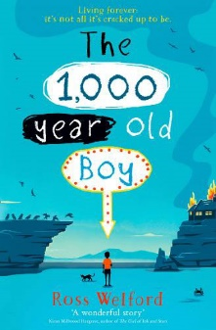 | 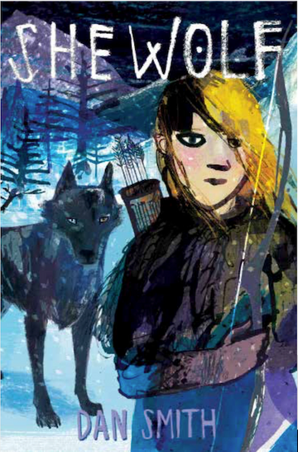
The Buried Crown Ally Sherrick | Monster Slayer Brian Patten & Chris Riddell | The Genius of the Anglo-Saxons Izzy Howell | The 1,000 year old Boy  Ross Welford | She Wolf  Dan Smith

Key Dates

Monday 18th September | The Railway Children (theatre show in school)
Friday 6th October | Harvest Festival 9am at St Mary’s
Friday 20th October | Showcase Afternoon (parents welcomed into school at 2:30pm)
Thursday 26th October | Firework Disco
Friday 27th October | Colour Run
Friday 27th October | SCHOOL CLOSES for Half Term

Many thanks for your cooperation and support. I look forward to working with all of you to ensure that your children have an excellent and enjoyable year in my class.

Should you require any further information, please do not hesitate to get in touch.

Mrs Cat Lang
Cover Teacher

