Dear Parents/Carers,

Welcome to Burn Class’s Autumn 1 newsletter. You will receive a class newsletter every half term to keep you informed of all the things happening in our class. All the children have made an excellent start to the new school year and settled well into their new class.

Curriculum
In English this half term, the children will continue to develop their handwriting, spelling and knowledge of grammar and punctuation. We will be using the book ‘The Whale’ by Ethan and Vita Murrow to help us to develop descriptive sentence writing culminating in a setting description and newspaper report. Our first reading for pleasure book is ‘The Highland Falcon Thief’ by M.G. Leonard and Sam Sedgman.

In maths, we are currently focussing on place value for numbers of up to 7 digits (e.g. understanding how to break these numbers down and compare them). We will then move onto applying this understanding to work on the four operations, addition, subtraction, multiplication and division.

This half term, our history topic is ‘How did England change during the settlement of the Anglo-Saxons and Vikings?’.​ The children will learn about British history between 400 AD and 1066 AD, with a focus on the invasions and settlements during this period. We are planning a trip to Jorvik in York to support the children’s learning within this topic and we will send another letter with further information about this trip soon.

In our science work, Burn class are going to focus on sound whilst carrying out experiments and using a scientific process. In RE this half term, our learning is based around the enquiry question: ‘What is the deeper meaning of festivals?’. We will explore what we celebrate and why, and the children will have many opportunities to share their own beliefs and reflections. Our computing work will be based around safe and accurate searching alongside key online safety messages. The children will also continue to develop their French with an initial focus on conversation. There will also be lots of opportunities for creativity, including painting in art with a focus on light and dark and singing in music.

PE
PE this half term will usually be on a Monday and a Friday. PE kits should be in school all week to allow for any changes in timetable. Children are not permitted to wear earrings for PE.

Homework
We are true believers that time at home is for different types of activities and we love to hear what the children have achieved whilst they are not at school. We know there are many talents in Burn Class and that the children attend many classes, groups and clubs out of school time - which is fantastic. However, parental support is invaluable in a child’s learning and regular homework this year will benefit children’s learning.

Burn class will be set weekly homework to build on, and consolidate, class learning. Children are expected to be able to complete this task independently and for it to take approximately 20 minutes. Homework will be set on a Friday and is due the following Wednesday.

Reading
Reading and enjoying stories at home is imperative to developing a child’s reading skills. Please record in the home reading record each time your child reads at home. Please make sure reading records come to school every day. Children read at school frequently but this is not always recorded in the home reading record.

Here at Masham C.E. Primary School, our aim is to promote a love of reading in all our children. Reading and enjoying stories at home is imperative to developing a child’s reading skills. Even though many of the children are now reading fluently, regular reading aloud has been shown to help children to continue to develop their comprehension and confidence with texts.

Parents often ask us for recommendations of suitable books to read at home. Below is a list of high-quality texts that we think you and your child would enjoy reading together this term.

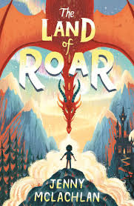 | 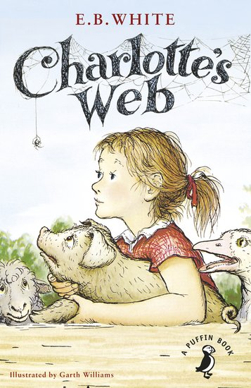 | 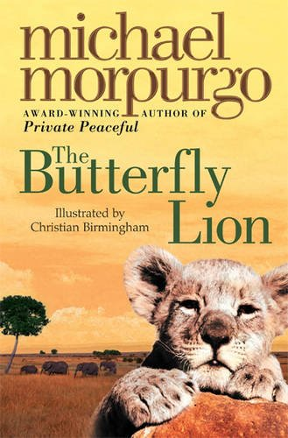 | 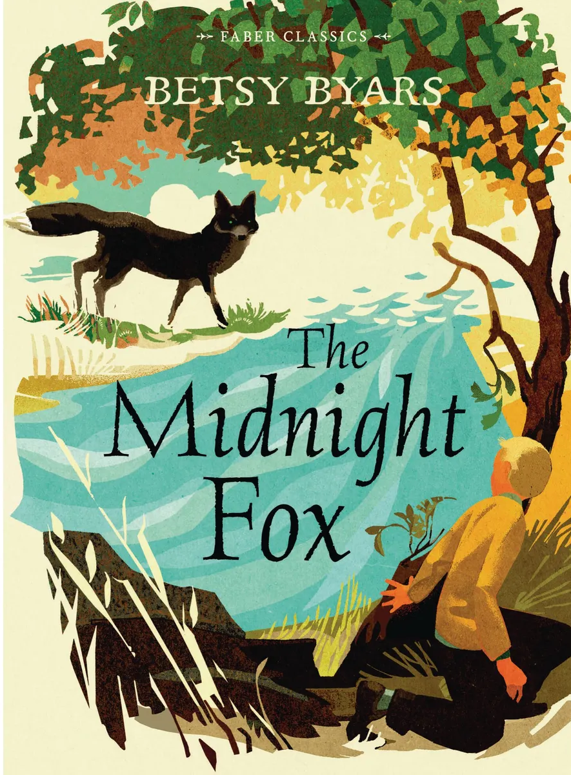 | 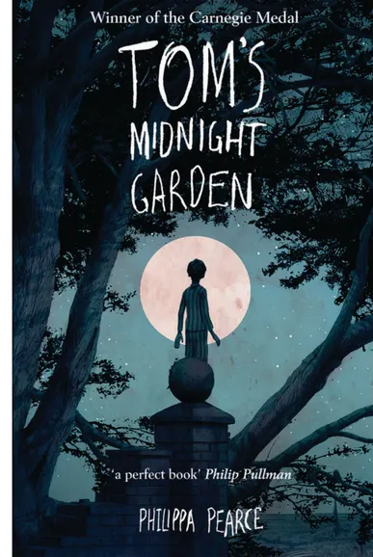
The Land of Roar  Jenny McLachlan | Charlotte’s Web  E.B. White | The Butterfly Lion  Michael Morpurgo | The Midnight Fox  Betsy Byars | Tom’s Midnight Garden  Philippa Pearce

Key Dates

Monday 18th September | The Railway Children (theatre show in school)
Friday 6th October | Harvest Festival 9am at St Mary’s
Friday 20th October | Showcase Afternoon (parents welcomed into school at 2:30pm)
Thursday 26th October | Firework Disco
Friday 27th October | Colour Run
Friday 27th October | SCHOOL CLOSES for Half Term

Many thanks for your cooperation and support. I look forward to working with all of you to ensure that your children have an excellent and enjoyable year in my class.

Should you require any further information, please do not hesitate to get in touch.

Miss Olivia Barber
Burn Teacher

